$12

$13

$14

***$13***

$14

$15 $16 $15

$14 $14 $15 $14

$13 $13 $13

$15 $15 $15

$15

$13 $8

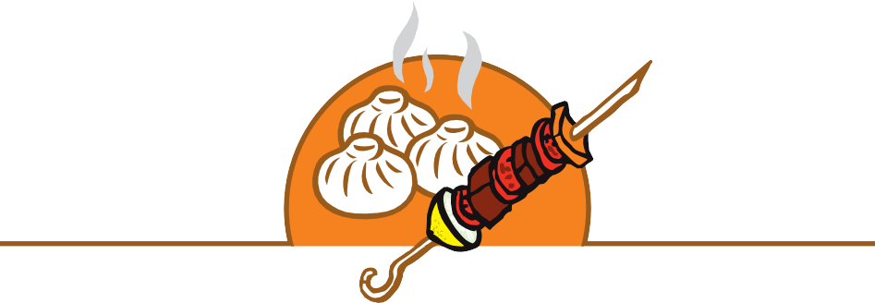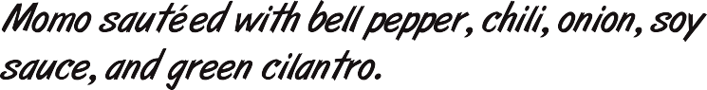

$16

$15 $14 $14

***$2 $2 $2 $2***